About

### Larry

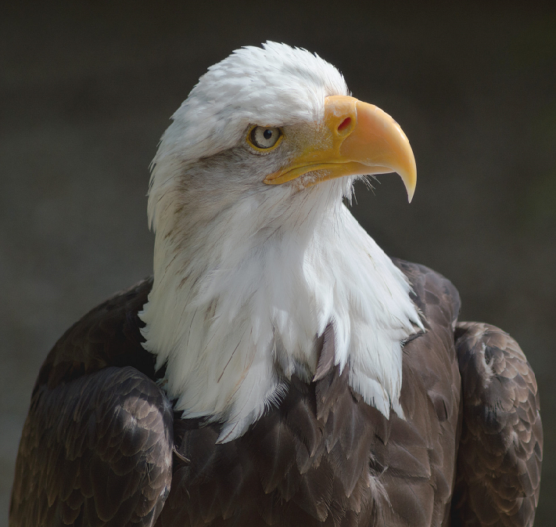

Larry has been growing out his hair.

### Nour

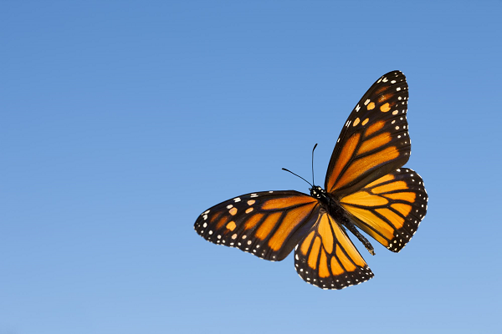

Nour, in cosplay as a butterfly. Pretty spot on, eh?

OH: Thursday, 9am - 10am

### Nathan

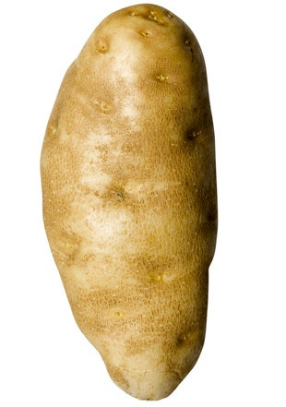

Nathan is a professional potato.

OH: Tuesday, 12:30am - 1:30pm

### The Catscot

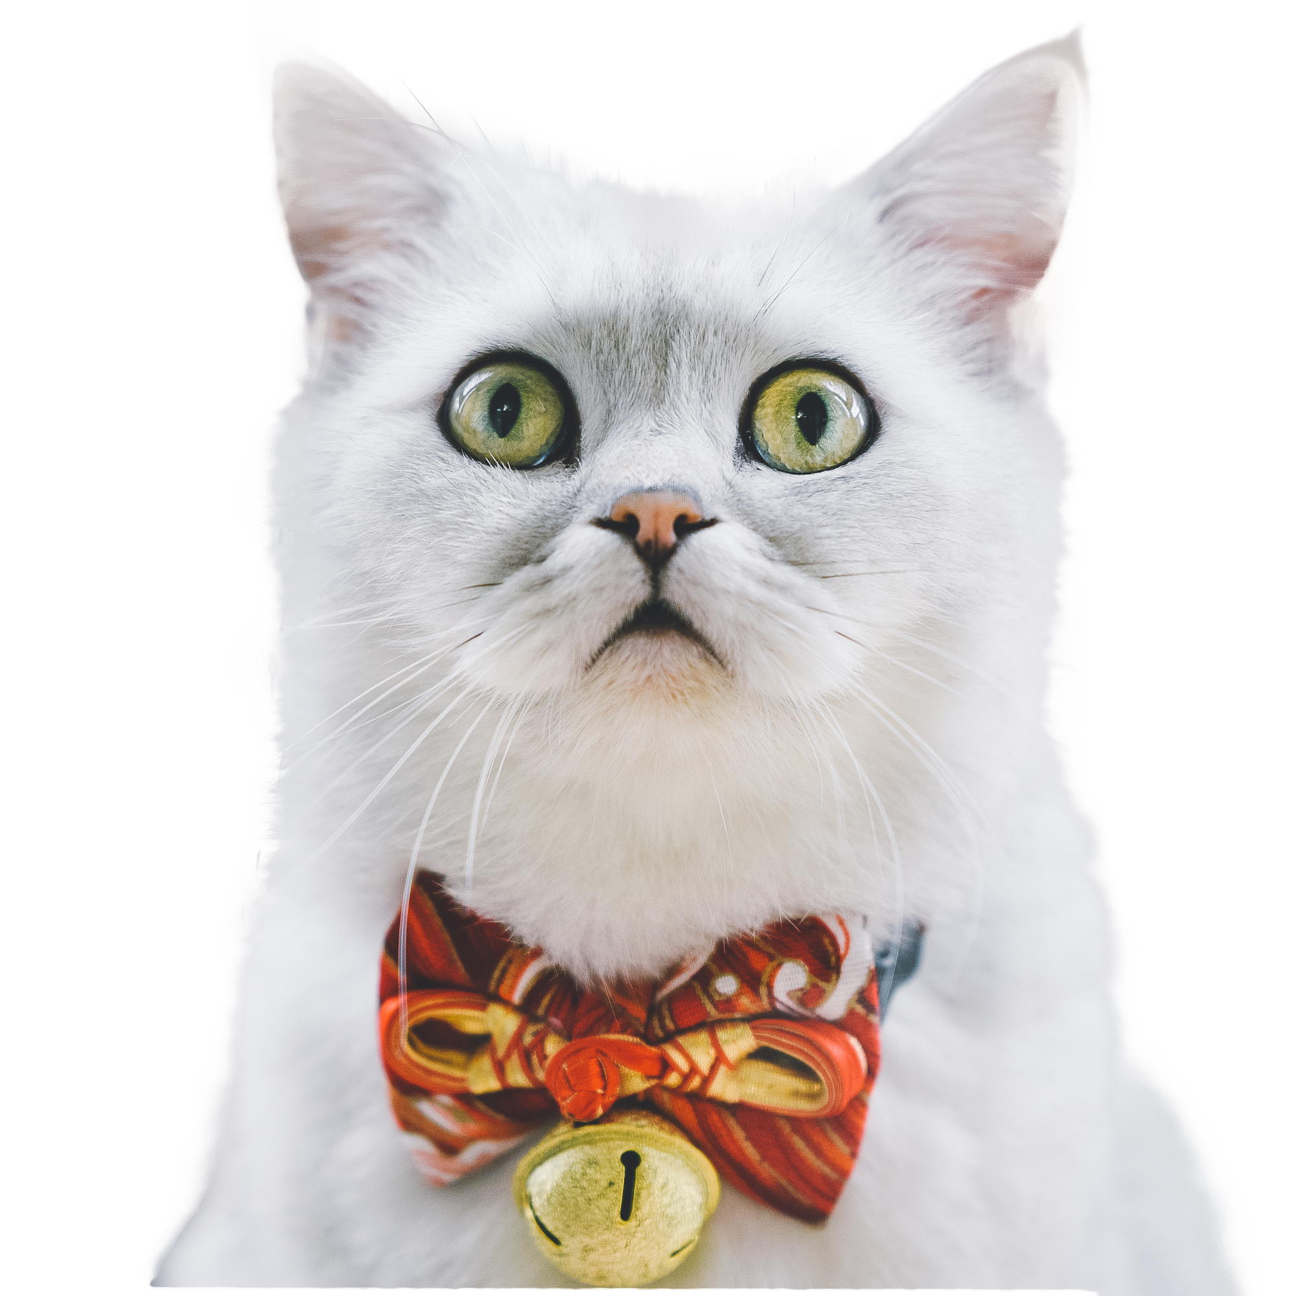

Our little mascot in the upper-left hand corner was Designed courtesy of 699pic at [pngtree.com](https://pngtree.com/freepng/cute-cat_5644947.html?sol=downref&id=bef)